Specification
  - Extrusion: RECTANG 20

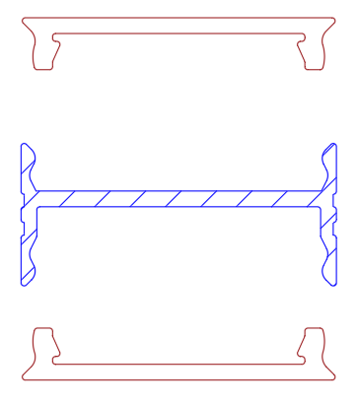

- The extrusion shall be made of aluminum alloy EN AW 6060.
- The extrusion shall be available in following surface finishes:
  - Blank
  - Anodized natural (thickness 15µm)
  - Anodized black (thickness 15µm)
  - Coated with polyester powder-coating in all standard RAL-colors
- The extrusion shall serve as cooling for the LEDs.
- The extrusion shall have following dimensions 20m x 10mm.
- The extrusion shall be available in lengths up to 6m.
- The extrusion shall fit a PCB of maximum 17mm
- The extrusion shall weigh max 0,09 kg/m
- The extrusion shall be compatible with aluminum mounting profiles on both sides.
- The extrusion shall have a compatible fully closed endcap.
- The extrusion shall have compatible endcap with hole for cable.

